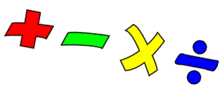

Learning outcome: To count in multiples of 5 ( five)
Practise counting in multiples of five. This means saying “ 5,10,15,20,25,30,35,40,45,50”
As you count put up a finger – at the end you should have 10 fingers up.
That means there are ten five’s to make 50. How many fives to make 30? 15? 45?
Use your 100 square. Look at the multiples of five, see where they are. Can you see a pattern?
Hold up your two hands. How many groups of 5 can you see?
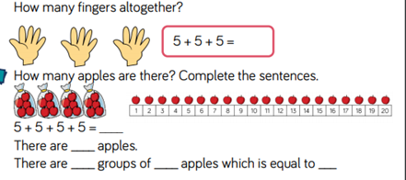
( We also count in 5’s when we tell the time – ask your Mum or Dad about telling the time)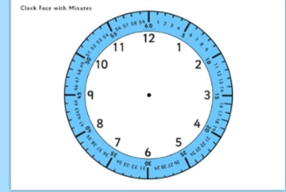 Literacy
When I go for a walk enjoy looking at nature - trees, and animals, and hills. Sometimes nature reminds me of something else. For example a tree trunk might look like a house.
Have a look at this picture. What can you see?
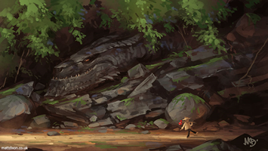
Write 5 sentences to describe this picture. rocks branches walking looking

I hope you all enjoyed discussing what your favourite pet would be.
This week’s discussion is about seasons. We know there are 4 seasons – Spring, Summer, Autumn and Winter. Think about 2 of them - Summer and Winter. Which is the best and why?

.

