Subject | Week 14
English | Comprehension  Complete the attached reading comprehension about the My Space Journey.
Grammar  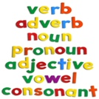 | Grammar revision  Try the grammar challenges, which bring together some of the things you have been practising over the last weeks.
Maths | White rose hub: https://whiterosemaths.com/homelearning/year-5/  Children should watch the daily videos and try the attached exercises for Week 5 Lesson 1 – Add and Subtract Fractions.
Discussion point with your family | Which would you choose if you could only have one in your life and why?
If you would like access to the answers sheets then please email enquiries@st-michaels.school

