Xc

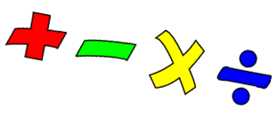

In Year 1 we look at numbers represented in different ways. The children will have used this practical equipment. This week is a revision of more than/less than.
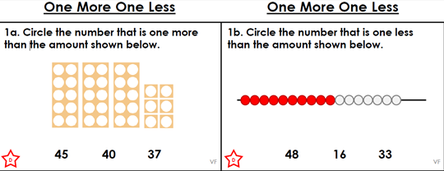
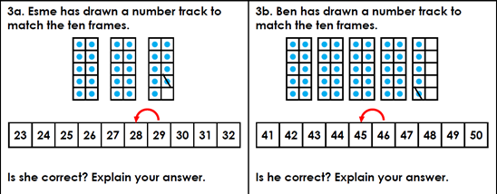

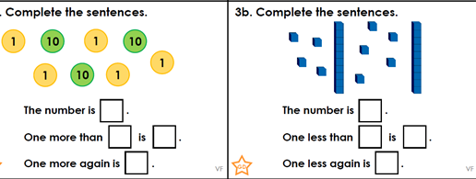

Also this week – practise counting up to 100.
Then count backwards from 100. Backwards is tricky but each day you might get further than the day before. Keep trying until you can do it without any mistakes. 😊

Literacy
This week let us try some comprehension questions. This means answering questions about something you have read or something that someone has read to you. Ask someone to help you read this part of the story, and then try and answer the questions in red.
The book – The Gruffalo by Julia Donaldson
…..................................................................................................................................................................
A mouse took a stroll through the deep dark wood.
A fox saw the mouse and the mouse looked good.
- Where did the mouse take a stroll?
- What did the fox see?

“Where are you going to, little brown mouse? Come and have lunch in my underground house.”
“It’s terribly kind of you, Fox, but no – I’m going to have lunch with a gruffalo.”
“A gruffalo? What’s a gruffalo?”
“A gruffalo! Why don’t you know?”
- Who is the mouse having lunch with?
- Where does the fox live?

“He has terrible tusks, and terrible claws, and terrible teeth in his terrible jaws.”
“Where are you meeting him?”
“Here, by these rocks. And his favourite food is roasted fox!”
“Roasted fox! I’m off! “ Fox said. “Goodbye little mouse,” and away he sped.
- What does the Gruffalo look like?
- What is the Gruffalo’s favourite food?
- Which word tells you how the fox moved?

Last week you discussed which was your favourite season between summer and winter.
Can you guess what Mrs Simonson and Mrs Exley said? Here’s a big clue ….

This week we are thinking about food.
If you had to go and stay for 2 days on an island with no shops, and you could only take
10 things to eat what would you take?

2 days ???
Would you take lots of sweets?
Would you get tired of eating sweets?
Would you take vegetables? Fruit?
Talk about this with your family – what would they take?

.

