Year 3 learning from Home
Subject | Week 12 – 15/06/2020
English | Read the text Earth Day and answer the questions.
Grammar  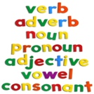 | Grammar –Word work Grid – V2  Complete the second row of the grid using the Y3 and 4 Spelling you got in your home learning pack.
Maths | Complete finding amounts of money sheet and challenge.
Discussion point with your family | How does it feel now we are allowed to meet up with some friends and family? Is it scary? Are you happy to meet your friends again?
If you would like access to the answers sheets then please email enquiries@st-michaels.school

