Year 3 learning from Home
Subject | Week 4 – 27/04/2020
English  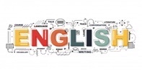 | Read one of your favourite books and write a report about it.  Write the title, the author, what the book is about, your favourite character and why.
Grammar  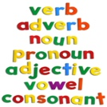 | 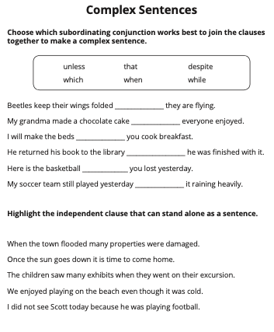  Grammar – complex sentences
Maths | 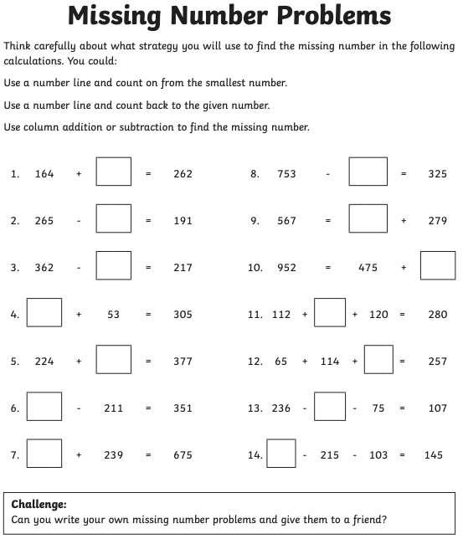
Discussion point with your family | Is it our responsibility to look after the environment? Discuss with people in your house.
If you would like access to the answers sheets then please email enquiries@st-michaels.school

