Xc

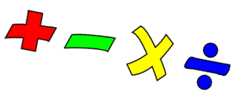

This week we are adding equal groups ( in preparation for multiplication)
Parents: If you are helping your child please talk of “groups of” or “lots of” as this will be the terminology we use to introduce multiplication
For example in image 2 below (the sweets) there are 3 groups of 2 sweets/ 3 lots of 2 sweets
-------------------------------------------------------------------------------------------------------------
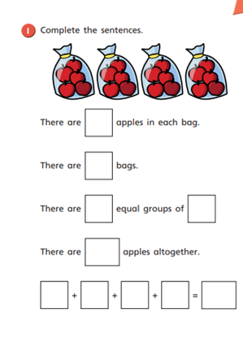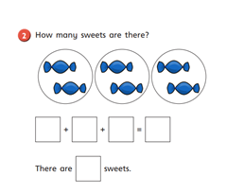

Literacy
Read the text below. Then answer the questions
- What part does Jess want to play ? ( look at page 4)
- What does Jess have that will help her be a witch? ( look at page 5)
- What does the teacher ask her to do? ( look at page 6)
- Why do you think Jess got the job as a witch? ( look at pages 8 and 9)

People have different jobs. Think about people you know and what jobs they do.
Perhaps they work in a shop, or a hospital. Perhaps they fix cars or drive a taxi.
If you were a grown up – what would be your best job?
Talk to your family about your best job, and tell them why you would like to do this job.

.

