Subject | Week 8
English | Using fronted adverbials – sheets attached below  Children should write sentences to describe what is happening in the images, and use fronted adverbials to add more detail to their sentences.  A fronted adverbial is word or phrase that is placed at the start of a sentence. They are used to explain how, when or where something happens. A fronted adverbial is separated from the main sentence with a comma.  Children should then write a postcard about their dream summer holiday, using a range of fronted adverbials. They can use the template provided or a separate piece of paper.
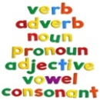  Spelling | Incorrect spellings  Children are required to identify which word is spelt incorrectly, and try to write the correct spelling of the word.
Maths | White Rose Video. Watch the videos under ‘Summer term- week 4’ then try to complete the activities. https://whiterosemaths.com/homelearning/year-4/  This isn’t something we have focused on in Year 4 this year so far so some children may find this difficult, it is best for them to just have a go.  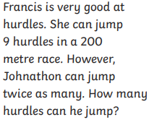  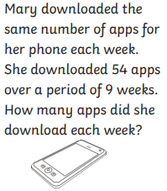  There are two word problems bellow to have a go at. They use the skills we focus on in Daily Practice.
Discussion point with your family | What is your favourite time of the year? Winter, Spring, Summer Autumn?  Which is your favourite season? Is there a special occasion you celebrate in that season that makes it your favourite? Is your birthday in that season? Do you like the weather in that season?  You could then draw your favourite season and colour it in using colours linked to that season!
If you would like access to the answers sheets then please email enquiries@st-michaels.school

