Xc

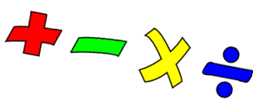

This week we are thinking about quarters. A quarter is 1 part out of 4 equal parts
For example The circle has been split into 4 equal parts. One part is green.
The green part shows one quarter.
Remember – the 4 parts have to be equal. They have to be the same size.
X This is not a quarter – because all the parts are not equal
-------------------------------------------------------------------------------------------------------------

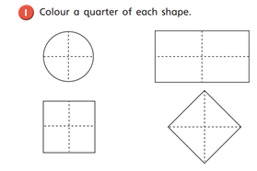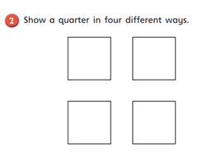
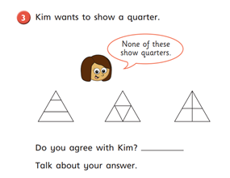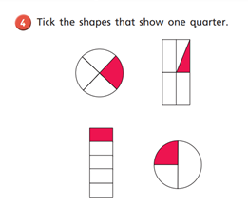

Also this week – practise saying the months of the year
January February March April May June July August September October November December
Which month is your birthday? Which month is today?

Literacy 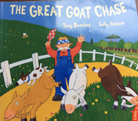

Try and read the text below. Ask a grown up to help you if you get stuck .
Then answer the questions
Mr Farmer grew some turnips in his field. The turnips were round and plump. One day he forgot to close the gate to the field, and three goats ran in. They could hardly believe their luck – they loved turnips and began to eat. Chomp. Chomp!
Mr Farmer looked out at his field. “ Oh no!” he shouted. He chased the goats, this way and that way, but he couldn’t get them out.
So, Mr Farmer got his dog. He told the dog to chase the goats out of the field. The dog chased the goats, this way and that way, but he couldn’t get them out.
So, Mr Farmer got his horse. He told the horse to chase the goats out of the field. The horse, with its long legs, chased the goats this way and that way, but he couldn’t get them out.
So, Mr Farmer got his bull. The bull had big horns. The bull chased the goats this way and that way, but he couldn’t get them out.
The Farmer, the dog, the horse and the bull all sat down and cried.
Just then a bee came buzzing past. “I’ll get those goats out of the field” she said
“ You? A teeny tiny bee?” said Mr Farmer
“ Just watch” buzzed the bee.
The bee flew into the turnip field. She buzzed around the goats and then shouted
“ If you don’t leave this field right now I will sting your bottoms!”
The goats ran as fast as they could, out of the field, down the lane and up the hill.
Well done buzzy bee!

- What 2 words ( adjectives) describe the turnips?
- What was the first animal to try and get the goats out?
- Why did the Farmer and the animals sit down and cry?
- Why did the Farmer think the bee would not be able to get the goats out?
- How do you think the bee felt at the end?

This week some of you are getting ready to come back to school, and some of you are staying at home to do your learning.
Remember - Everyone will be back at school eventually. At the moment we don’t know when that will be.
So this week the discussion is about coming back. Returning after a long time.
Think about the time when you will come back to school
What are you most looking forward to?
Friends? Teachers? The playground? The books? Writing stories?
Painting pictures? P.E in the hall?

Talk to your family about what you are most looking forward to.
--------------------------------------------------------------------------------------

.

