Xc

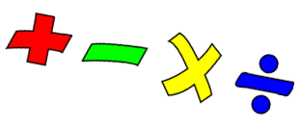

This week we are looking at finding half (Parents – these have been taken from White Rose maths)
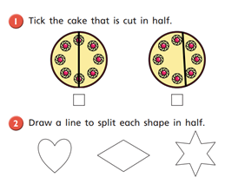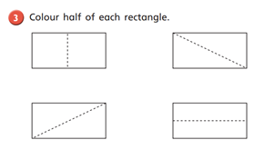
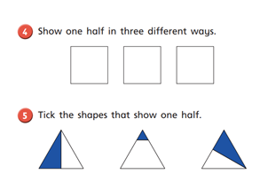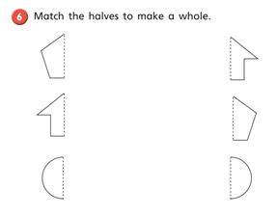

Also this week – keep practising counting up to 100 and backwards Play number tennis

Literacy
Try and read the text below. Ask a grown up to help you if you get stuck .
Then answer the questions
A New Pet

Tom was six. He lived in a flat with his Mum. The flat was on the top floor. It was very high up!
One day, Tom said to his Mum, “Mum, can I have a dog?”
But Mum shook her head and said, “No Tom, you can’t have a dog. There are no dogs allowed in a flat.”
Tom wanted to cry. Then he said, “Mum, can I have a cat?”
But Mum shook her head and said “No Tom, you can’t have a cat. There are no cats allowed in a flat.”
Now Tom did start to cry, “I want my own pet!” he shouted.
Mum patted Tom on the back and gave him a kiss, “Don’t cry Tom, I will see what I can do.”
The next day, when Tom got home from school, there was a small cage on the table. Tom was excited! He ran to look in the cage. In the cage was an orange hamster! Mum put the hamster in Tom’s hands.
Tom smiled and said, “I will call it Rusty. Thank you, Mum!”

Questions (Try and answer in full sentences.)

- How old is Tom?

- Where does Tom live?

- What pets did Tom want?

- How does Tom feel when Mum says “No?” How do you know this?

- How does Mum try to make Tom feel better?

- Why was Tom excited when he saw a cage on the table?

- What was in the cage?

- Why did Tom call his pet, ‘Rusty?

- How do you know Tom is happy about his new pet?

(Parents – see Mrs Clifford’s “Make a mood pot” – Home learning – Lessons from our staff)
This week we are thinking about our feelings. Sometimes we are happy, or excited and other times we are sad or grumpy or cross.
If you could give a colour for each of these feelings what would it be, and why?
For example : When I am feeling excited I would give it the colour yellow because that is a bright, sunshiny colour. When I am feeling grumpy I would give it the colour grey because rain clouds are grey.
Talk to your family about different feelings and try and link them to colours.

--------------------------------------------------------------------------------------

.

