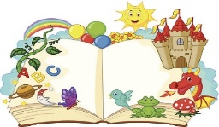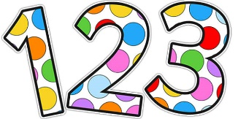

**Rhyme time:**

This week we’ll be recapping all our favourites:

* Sing nursery rhymes.
* Go on a sound walk.
* Use objects or instruments to make loud and quiet sounds.
* Think of initial sounds of words. E.g. egg starts with ‘e’ so does ‘elephant, envelope’ etc.
* Have a game of silly soup.

Now this would have been our last week together I hope you can think of some of happy times. Talk together about them. My happy memories are of when we baked and iced cakes and took them to Cruddas Park shopping centre to share with our community. I also loved all the stay and play sessions we had and of course the Christmas play, where you all tried your best and made me so proud. I’ll miss you lots, you’ve been my first Nursery class that I’ve taught and what a special class you’ve been! I’ll not be far away from you next year too so that will be nice, I’ll keep watching you grow.

I hope you and your families have a lovely summer, Take care, love Mrs Bonham xxx

**This is our final week of Maths so recap:**

* Counting songs,
* Numbers to 10 (and beyond),
* Recognising numbers 1-10,
* Matching amounts to the unit,
* Recap the shapes you now,
* Talk about their features such as number of sides and corners.