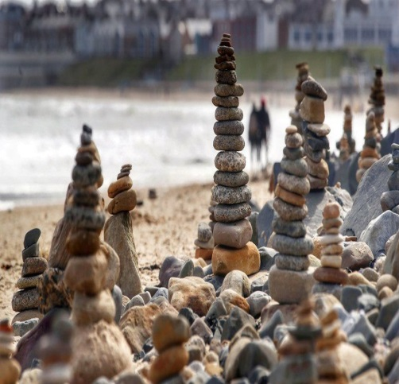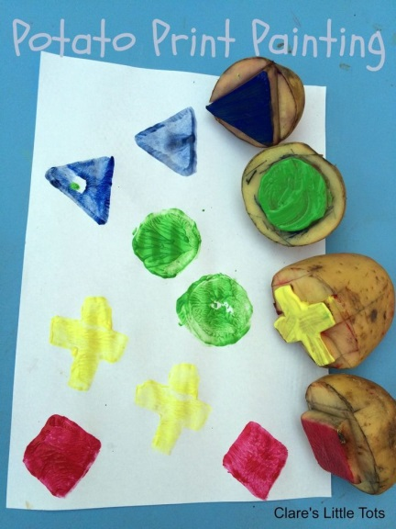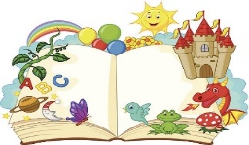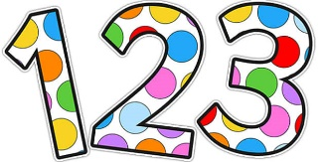supe

**Silly soup.** Can you remember our silly soup song?

*“I’m making lots of silly soup; I’m making soup that’s silly. I’m going to put it in the fridge to make it nice and chilly.”*

Get a pan and a spoon once you’ve sang the song find some of your toys or other ingredients to make a silly soup. This week focus on the letter I, add objects which start with the i sound.

**Fine motor.** At whitely bay beach they have been making stone towers like these. Can you build one? You’ll need to find flat stones and start with the largest on the bottom.

**Shape and repeating patterns:**

Can your parents help you by cutting shapes into Potatoes?

(Square, circle and triangle) Then use them to dip in paint and make patterns?

If you don’t have paint or potatoes, then finding objects to draw round each shape are fun to use too.

Repeating patterns are when you copy the same pattern again and again.

This week we have heard that we can go outdoors for longer and we can go further to exercise. Where are you excited about going to? I’m hoping to go further on my bike as I’m getting faster and fitter.

I’m excited to see you all soon, love Mrs Bonham xx