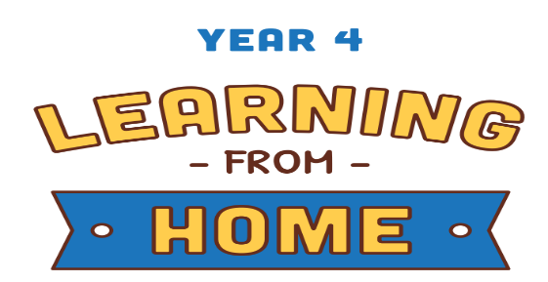

Subject | Week 6
English | Comprehension  Children should read the text “The Big Race” and complete the attached questions.  You could make actions us to go with each part of the story to help you understand they key parts.
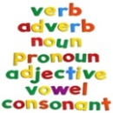  Grammar | Grammar Word Search  Children are required to find the grammatical terms listed in the word search attached below. Children can try and write a definition for what each mean, or give an example.
Maths | White Rose Video. Watch the videos under ‘Summer term- week 2’ then try to complete the activities. https://whiterosemaths.com/homelearning/year-4/  This isn’t something we have focused on in Year 4 this year so far so some children may find this difficult, it is best for them to just have a go. This week focuses on:  Lesson 1: Round decimals, Lesson 2: Halves and quarters, Lesson 3: Pounds and pence, Lesson 4: Ordering money, Lesson 5: Maths challenge.  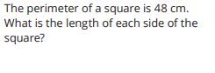  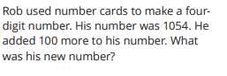  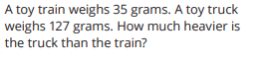  There are three word problems bellow to have a go at. They use the skills we focus on in Daily Practice.
Discussion point with your family | If you could make your whole house of out of food, what would you choose?  Which foods would work best for certain parts of the house? Think what would happen on a hot or cold day? How would you build it?  You could then draw your house made of food and label parts of the house with what it is made from!
If you would like access to the answers sheets then please email enquiries@st-michaels.school

