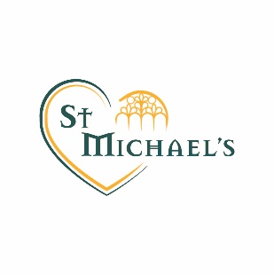

COVID-19 Update – Wednesday 18th March 2020
A message from Mrs Chapman:

I appreciate your patience and support in these very difficult times. As I am sure you are aware, the national picture and government advice is changing quickly, with the recent significant announcement of school closures on Friday. We are currently planning on how to move forward in the best possible way to support our community.

Tomorrow– Thursday 19 March 2020 – school will continue to be open with the same arrangements as today.

Despite the past week in school being ridiculously busy, the school has remained calm and orderly. As always, the staff of St Michael’s have been remarkable, we are so fortunate to have such a dedicated team who go that extra mile. Everyone is doing an extraordinary job in extraordinary times.

I would like to thank you all as parents and members of our school community for the amount of support you have shown for the school. Your kind words this week have meant a great deal.

We will of course let you know the next actions for St Michael’s as soon as we possibly can.

Mrs Chapman

