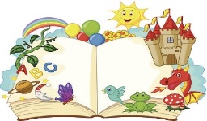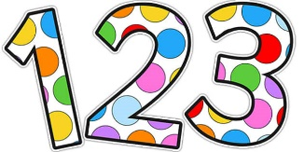superhero

**Counting and subtracting/taking away one:**

Using anything that you can gather to count such as stones, buttons, smarties, cars, jars etc. Sort them into bundles around 5-10 in each pile.

Ask your child to count them. (We find it easier to line them up and to pick up each object as they count them.) Then demonstrate that you are ‘taking one away’ by removing one.

Ask your child to count to check the total now. Explain that it is ‘one less’ because you ‘took one away’

If you have a pen and paper you could show them the numbers on a number line, this will help them to see that the number is now the one before it.

Can you make a den? How about finding something tall and covering it with a blanket. This can be your den. Invite an adult in to read a story and maybe share a snack. Enjoy lots of cuddles and chat about the pictures and the story.

I’m looking forward to seeing you all soon, love Mrs Bonham xx

**Silly soup.** Can you remember our silly soup song?

*“I’m making lots of silly soup; I’m making soup that’s silly. I’m going to put it in the fridge to make it nice and chilly.”*

Get a pan and a spoon once you’ve sang the song find some of your toys or other ingredients to make a silly soup. This week focus on the letter P, add objects which start with the p sound.

**Fine motor.** If you’ve got some paint can you paint a picture or experiment using your finger prints? Maybe you could paint a face or a flower or a monster.

If you look closely at the print can you spot the lines on your fingers?