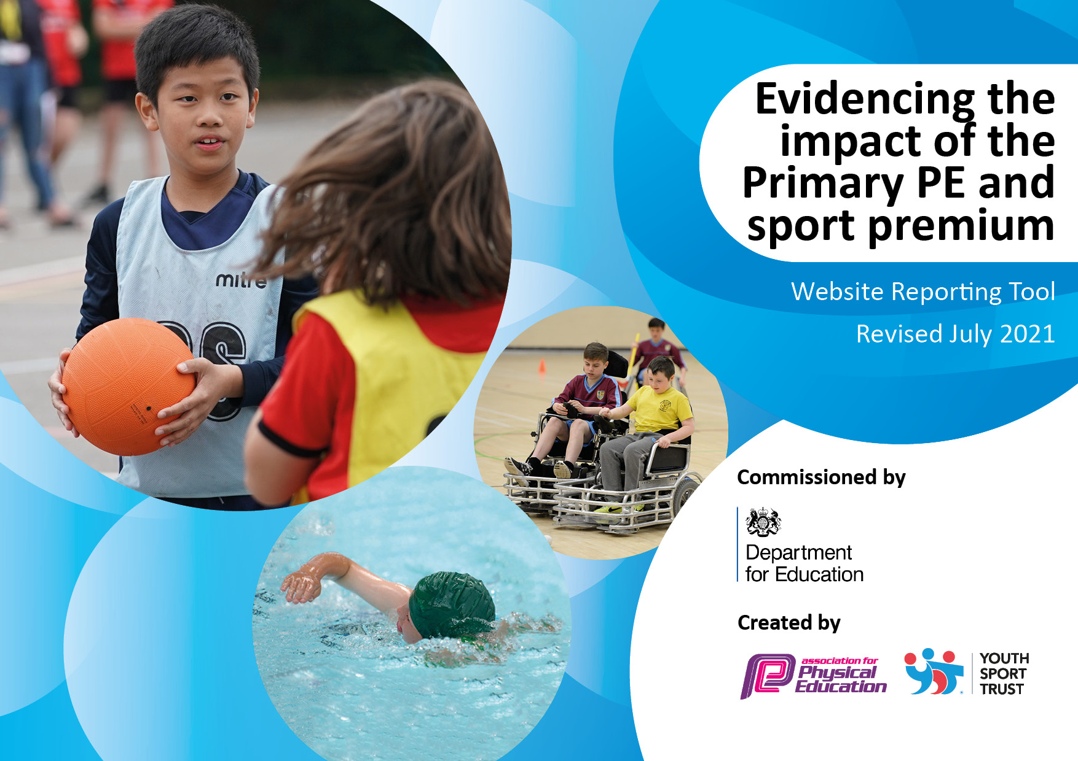
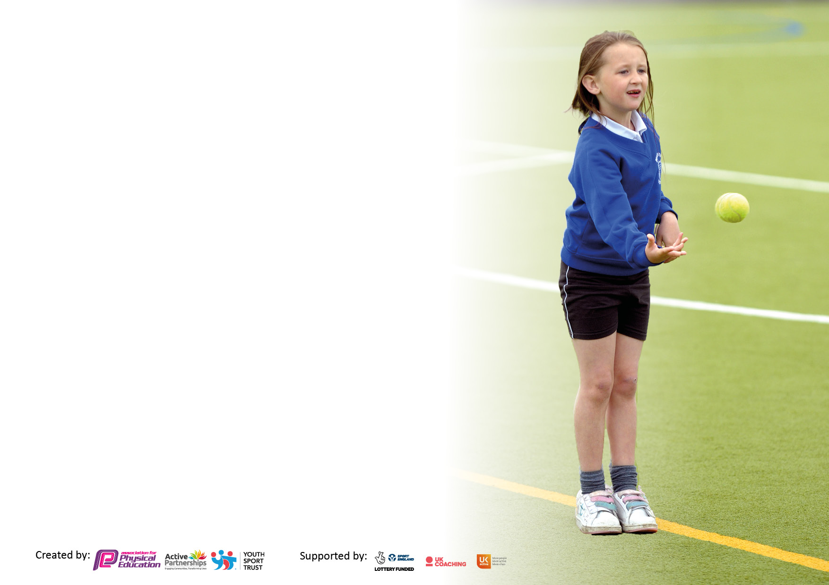

It is important that your grant is used effectively and based on school need. The Education Inspection Framework makes clear there will be a focus on ‘whether leaders and those responsible for governors all understand their respective roles and perform these in a way that enhances the effectiveness of the school’.

Under the Quality of Education Ofsted inspectors consider:
Intent - Curriculum design, coverage and appropriateness
Implementation - Curriculum delivery, Teaching (pedagogy) and Assessment
Impact - Attainment and progress

To assist schools with common transferable language this template has been developed to utilise the same three headings which should make your plans easily transferable between working documents.

Schools must use the funding to make additional and sustainable improvements to the quality of Physical Education, School Sport and Physical Activity (PESSPA) they offer. This means that you should use the Primary PE and sport premium to:

- Develop or add to the PESSPA activities that your school already offer
- Build capacity and capability within the school to ensure that improvements made now will benefit pupils joining the school in future years
- The Primary PE and sport premium should not be used to fund capital spend projects; the school’s budget should fund these.

Pleasevisitgov.ukfortherevisedDfEguidanceincludingthe5keyindicatorsacrosswhichschoolsshoulddemonstrate animprovement.Thisdocumentwillhelpyoutoreviewyourprovisionandtoreportyourspend.DfEencouragesschools to use this template as an effective way of meeting the reporting requirements of the Primary PE and sport premium.

We recommend you start by reflecting on the impact of current provision and reviewing the previous spend.

Schools are required to publish details of how they spend this funding, including any under-spend from 2019/2020, as well as on the impact it has on pupils’ PE and sport participation and attainment. All funding must be spent by 31st July 2022.

We recommend regularly updating the table and publishing it on your website throughout the year. This evidences your ongoing self-evaluation of how you are using the funding to secure maximum, sustainable impact. Final copy must be posted on your website by the end of the academic year and no later than the 31st July 2021. To see an example of how to complete the table please click HERE.

Details with regard to funding
Please complete the table below.

Total amount carried over from 2019/20 | £2265
Total amount allocated for 2020/21 | £17,000
How much (if any) do you intend to carry over from this total fund into 2021/22? | £5,865
Total amount allocated for 2021/22 | £17,000
Total amount of funding for 2021/22. To be spent and reported on by 31st July 2022. | £22,865
Swimming Data
Please report on your Swimming Data below.

Meeting national curriculum requirements for swimming and water safety.

N.B. Complete this section to your best ability. For example you might have practised safe self-rescue techniques on dry land which you can then transfer to the pool when school swimming restarts.
Due to exceptional circumstances priority should be given to ensuring that pupils can perform safe self rescue even if they do not fully meet the first two requirements of the NC programme of study
What percentage of your current Year 6 cohort swim competently, confidently and proficiently over a distance of at least 25 metres?  N.B. Even though your pupils may swim in another year please report on their attainment on leaving primary school at the end of the summer term 2020.  Please see note above | 20%
What percentage of your current Year 6 cohort use a range of strokes effectively [for example, front crawl, backstroke and breaststroke]?  Please see note above | 20%
What percentage of your current Year 6 cohort perform safe self-rescue in different water-based situations? | 20%
Schools can choose to use the Primary PE and sport premium to provide additional provision for swimming but this must be for activity over and above the national curriculum requirements. Have you used it in this way? | No

Action Plan and Budget Tracking
Capture your intended annual spend against the 5 key indicators. Clarify the success criteria and evidence of impact that you intend to measure to evaluate for pupils today and for the future.

Academic Year: 2021/22 | Total fund allocated: | Date Updated:
Key indicator 1: The engagement of all pupils in regular physical activity – Chief Medical Officers guidelines recommend that primary school pupils undertake at least 30 minutes of physical activity a day in school |  |  |  | Percentage of total allocation:
 |  |  |  | %
Intent | Implementation |  | Impact
Your school focus should be clear what you want the pupils to know and be able to do and about  what they need to learn and to  consolidate through practice: | Make sure your actions to achieve are linked to your intentions: | Funding allocated: | Evidence of impact: what do pupils now know and what can they now do? What has changed?: | Sustainability and suggested next steps:
To build on and increase the opportunities available for children to engage and achieve 30 active minutes daily.  To continue to encourage children to engage in activities each day so they achieve their 30 active minutes. | - PE lead to attend CPD to understand ways to approach daily active minutes. Further discussion to take place during termly development meetings.  - PE lead to feedback during staff CPD in staff meeting time. Ensuring all staff understand the purpose and the impact Covid has had on our Children.  - Ensure Daily mile/daily active minutes are happening daily through the school and that children are made aware of the benefits.  - Review and increase after school club provision and ensure every year group has an opportunity to engage.  - Revise and refresh the after-school programme each term.  - Train young leaders to deliver activities during break and lunch times in the KS1 yard.  - Reconnect with local clubs and re-establish club links with external providers to signpost children to physical activities and sport activities outside of school. | £2,500 | - All classes timetabled to provide daily active exercise.  - Year 5 have received playground leaders training and the KS1 yard is seeing a more engaged and active lunchtime.  - Year 5 young leaders have developed their own confidence through leadership opportunities.  - Some children have engaged in after school at a minimal cost although uptake has been slow. | Children to understand why it is important, the purpose, to take part in daily active time.  Use Pupil voice to continue to look at how to increase engagement in after school clubs.  Ensure Playground leader training occurs early in Autumn term for next cohort of leaders.
Key indicator 2: The profile of PESSPA being raised across the school as a tool for whole school improvement |  |  |  | Percentage of total allocation:
 |  |  |  | %
Intent | Implementation |  | Impact
Your school focus should be clear what you want the pupils to know and be able to do and about  what they need to learn and to  consolidate through practice: | Make sure your actions to achieve are linked to your intentions: | Funding allocated: | Evidence of impact: what do pupils now know and what can they now do? What has changed?: | Sustainability and suggested next steps:
To celebrate the achievements of our children to develop reengagement in sport.  To reengage, grow and develop our young leaders to help them to engage in leadership opportunities relating to P.E. and School sport.  Encourage children by providing and developing Healthy Active Lifestyle by providing opportunities and raising the confidence in children so that they remain motivated to participate | - Celebration assemblies established and timetabled. To celebrate schools and outside sporting achievements.  - Sports day. Timetable, organise and promote. Invite parents.  - Train playground leaders to deliver activities to promote sport amongst peers, particularly in KS1.  - Purchase the Silver SLA from the Newcastle PE and School Sport Service  - Attend Young Leaders Celebration Event. | £9,500 | - Children are keen to represent the school and be celebrated through the school community. Parents are hearing about our success.  - Parental engagement through support and encouragement in competition and sports events such as PTFA mile and sports day.  - Playground leaders have increased the number of children participating in active minutes during the school day.  - Confidence in leadership has increased in year 5.  - Healthy school award achieved. | Continue to celebrate success and promote to our wider community.  Ensure Playground leader training occurs early in Autumn term for next cohort of leaders.

Key indicator 3: Increased confidence, knowledge and skills of all staff in teaching PE and sport |  |  |  | Percentage of total allocation:
 |  |  |  | %
Intent | Implementation |  | Impact
Your school focus should be clear | Make sure your actions to | Funding | Evidence of impact: what do | Sustainability and suggested
what you want the pupils to know | achieve are linked to your | allocated: | pupils now know and what | next steps:
and be able to do and about | intentions: |  | can they now do? What has
what they need to learn and to |  |  | changed?:
consolidate through practice:
To continue to increase the confidence and competence of teachers in order to deliver high quality P.E. and improved outcomes for children. | - P.E. assessments to be carried out by class teachers and SHHS P.E. teachers.  - PE lead to Plan curriculum with SHHS P.E. Teachers ensuring as best can that staff can prepare pupils for festival and competition.  - Facilitate booster sessions to help less-able/active children to improve their fundamental movement skills (delivered by Newcastle PE and School Sport Service)  - PE Lead to attend CPD sessions (6 opportunties) as part of the Silver SLA provision.  - Engage in the Newcastle PE and School Sport Service CPD timetable.  - Daily mile/Active 30 staff meeting to encourage staff to get involved and introduce to new staff. | £6,500 | - Staff supported SHHS Teachers in developing assessment approaches where possible, although covid restrictions prevented face to face interaction.  - Curriculum planned for the full year with competition and festivals included.  - Regular updates between SHHS staff and PE lead/ teachers occurred half termly.  - After school sports clubs started again, children reingaged. Children selected using assessment data and discussion with SHHS P.E. Teacher.  - PE lead continued to Engage and meet with Newcastle PE and SSS throughout the year.  - Active 30 continued across the school and timetabled, continuing to support our healthy school award. | - Regular cycle of review using student voice to shape provision. E.G. questionnaires, student council.  - Ensuring all staff are aware of the provision and share views, thoughts and opinions.
Key indicator 4: Broader experience of a range of sports and activities offered to all pupils |  |  |  | Percentage of total allocation:
Intent | Implementation |  | Impact
Your school focus should be clear | Make sure your actions to | Funding | Evidence of impact: what do | Sustainability and suggested
what you want the pupils to know | achieve are linked to your | allocated: | pupils now know and what | next steps:
and be able to do and about | intentions: |  | can they now do? What has
what they need to learn and to |  |  | changed?:
consolidate through practice:
Additional achievements:  Encourage children by providing and developing Healthy Active Lifestyle by providing opportunities and broadening horizons raising the confidence in children so that they remain motivated to participate | - Engage in the Healthy Active Lifestyles Program facilitated by the Newcastle PE Service  - Engage in opportunities from other external providers.  - Promote opportunities from external clubs and deliverers that the children and families can engage in outside of school.  - Prepare and participate in the Newcastle Schools Dance Festival 2022 – employ and external dance coach to choregraph and prepare the children for the Dance Festival. | £800 | - Where possible all classes attended their organised Healthy active lifestyle event.  - Cricket, Basketball and Swimming delivered by an external provider giving a broader experience outside the curriculum.  - Most Games, competition and disability events attended as planned.  - PE board, assemblies, social media and website used to promote achievements and engagement for children and families outside of school.  - Year 1 enjoyed an afternoon celebrating the dance festival and their participation by watching the whole performance with snacks. | - All classes to continue attending the Healthy active lifestyle event.  - Continue to attend trust opportunities and events as they arise through the academic year.  - Continue to use the PE board, assemblies, social media, seesaw and website to promote achievements and engagement for children and families outside of school.

Key indicator 5: Increased participation in competitive sport |  |  |  | Percentage of total allocation:
 |  |  |  | %
Intent | Implementation |  | Impact
Your school focus should be clear | Make sure your actions to | Funding | Evidence of impact: what do | Sustainability and suggested
what you want the pupils to know | achieve are linked to your | allocated: | pupils now know and what | next steps:
and be able to do and about | intentions: |  | can they now do? What has
what they need to learn and to |  |  | changed?:
consolidate through practice:
Continue to Raise and encourage participation in competitive opportunities | - Continue to engage with the school games programe and reengage with competitions children.  - Link curriculum to competitions and Commonwealth games in July.  - Prepare children for Healthy competition using NGB formats, support from NSSPES,  - Apply for school games mark, target gold.  - Engage in the Catholic Competitions opportunities offered.  - Engage in additional; competition opportunities offered from external providers. | £900 | - Increased participation in School games competition.  - Sports days linked to The Commonwealth games and shared with families as well as children.  - Achieved the Healthy award.  - Achieved the Gold schools sports award. | - Continue to plan curriculum to link to competition.  - Look at School games competition Calander and look at new competitive opportunities.  - Engage with links with external clubs/providers to develop competition opportunities.

Signed off by
Head Teacher: | Charlotte Chapman
Date: | 11.7.22
Subject Leader: | Jennifer Bonham
Date: | 6th July 2022
Governor: | Belinda Ward- to be reviews at LGC meeting
Date: | 19th July 2022

