Year 3 learning from Home
Subject | Week 13 – 22/06/2020
English | Read the text Fossils and answer the questions.
Grammar  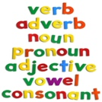 | Grammar –Word work Grid – V2  Complete the third row of the grid using the Y3 and 4 Spelling you got in your home learning pack.
Maths | Complete finding Multiplying 2-digits by 1-digit.
Discussion point with your family | What do you miss about being in school? Ask your parents what they miss at this strange time?
If you would like access to the answers sheets then please email enquiries@st-michaels.school

