Subject
English | 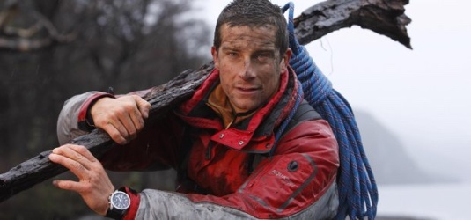  Write a Biography- Bear Grylls  This week you are going to follow the instructions below and then write a biography.
Maths | White Rose  Watch the videos on Summer term (w/c June 1^{st)} fractions to percentages https://whiterosemaths.com/homelearning/year-6/.  Then have a go at the worksheets below.  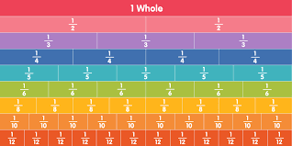
Discussion point with your family | 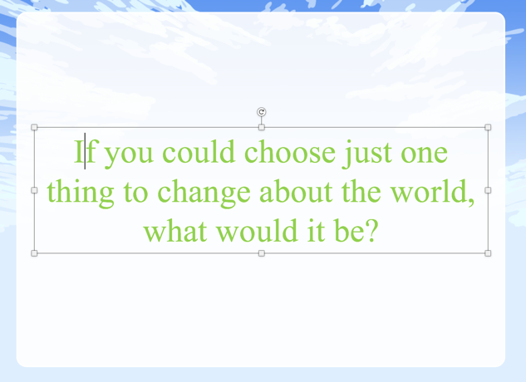  What do you think? Would you tackle poverty and health issues? Would you give everyone money? Or would you stop climate change?
Faith in Action Award | Task: Help out at dinner time by doing the dishes -take a picture and send it to school email enquiries@st-michaels.school so we can out it on the school website and school facebook page.
If you would like access to the answers sheets then please email enquiries@st-michaels.school
Bear Grylls
Bear Grylls is an adventurer, popularly known for his survival tactics in his television series Man vs. Wild.
Since he was a child, he has always been interested in adventure sports such as: mountaineering, sailing, and sky diving.
He is also known for hiking in the Himalayan Mountains of Sikkim and West Bengal, and on 16th May 1998, he climbed Mount Everest and registered his name in the ‘Guinness Book of Records.’
Watch these short survival skill tips from Bear Grylls:
https://www.youtube.com/watch?v=whua9J4p870
https://www.youtube.com/watch?v=tJKZ7dkdcEs
https://www.youtube.com/watch?v=gzsMrlPx2d8
Biography
A biography is about somebody else’s life.
It is about a real person, but is not written by the person. It is written in third person.
The author must know a lot about the person and research the person, so that they can write a lot about them.
A biography describes key facts about a person. Such as, where, when and how they live (or have lived if the person is no longer alive)
It is written in chronological order.
Provides details that show events in a person’s life.
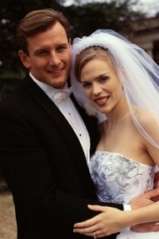
A biography might talk about a person’s achievements, things that have happened to them, and their likes and dislikes.
A biography will talk about how the person feels about different things.

It might talk about the work a person does or the things they believe in.
Task 1
Your first task is to research Bear Grylls. You can use the websites below to research about him and use the information to complete the planning sheet on the next few pages.
https://metro.co.uk/2018/06/26/bear-grylls-wife-age-children-career-television-7660757/
https://www.thefamouspeople.com/profiles/bear-grylls-6100.php
https://www.channel24.co.za/TV/FeaturedArticle/24-Facts-Bear-Grylls-20120314
Planning sheet
Make some notes using bullet points under each heading. Use a piece of paper
Bear Grylls
Early life
-
-
-
-
Career
-
-
-
-
Personal Life
-
-
-
-
Achievements
-
-
-
-
-
Now that you have your plan, you can use the information that you have collected to write your Biography.
Remember, your Biography needs to be your own writing. The next page shows you the features that you should include.

Below there is an example of a biography:

Now it’s time for you to write your Biography. Follow this layout for your writing:

Bear Grylls

Early Life
Career
Personal Life
Achievements

MATHS

