Subject
English | This week in literacy you will be looking at people who have inspired others during this lockdown period.  Your first task is to do a short comprehension on a newspaper article.  Next, you will some up and find out about inspirational people from all over the country.  Finally, you will write about your own experience and how you can inspire others. (follow the instructions below)
Maths | White Rose  Follow the instructions on the WhiteRose website (video) to help you work out the questions below. This week is summer term week 4 (w/c 11th may) multiplying, dividing fractions and finding fractions of an amount. link-https://whiterosemaths.com/homelearning/year-6/  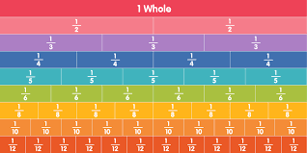
Discussion point with your family | If you could have a conversation with anyone in history, who would it be? And why?
Faith in Action Award | Task: -Play with a younger brother, sister or relative to help look after them. Take a picture and email enquiries@st-michaels.school so we can out it on the school website and school facebook page.
If you would like access to the answers sheets then please email enquiries@st-michaels.school

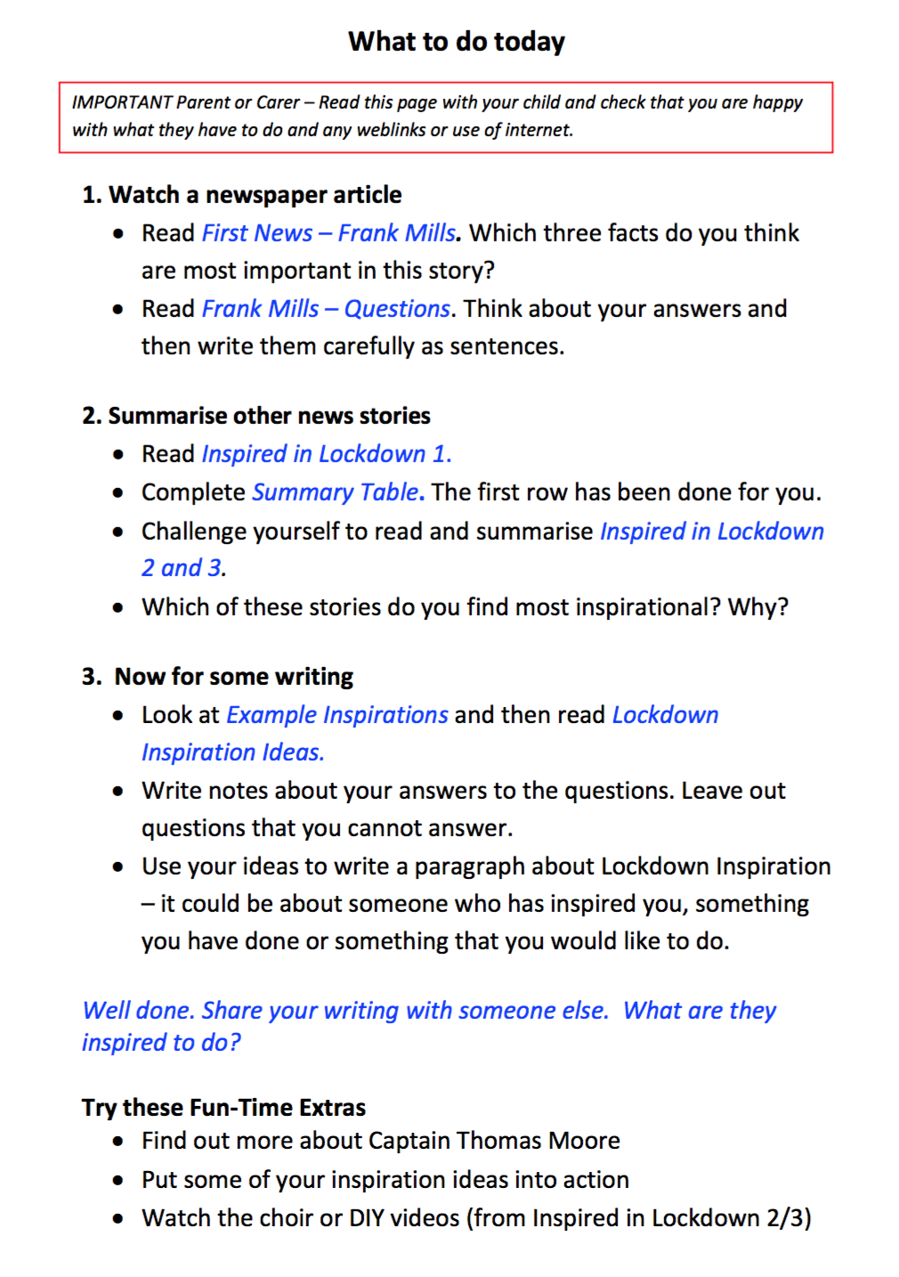

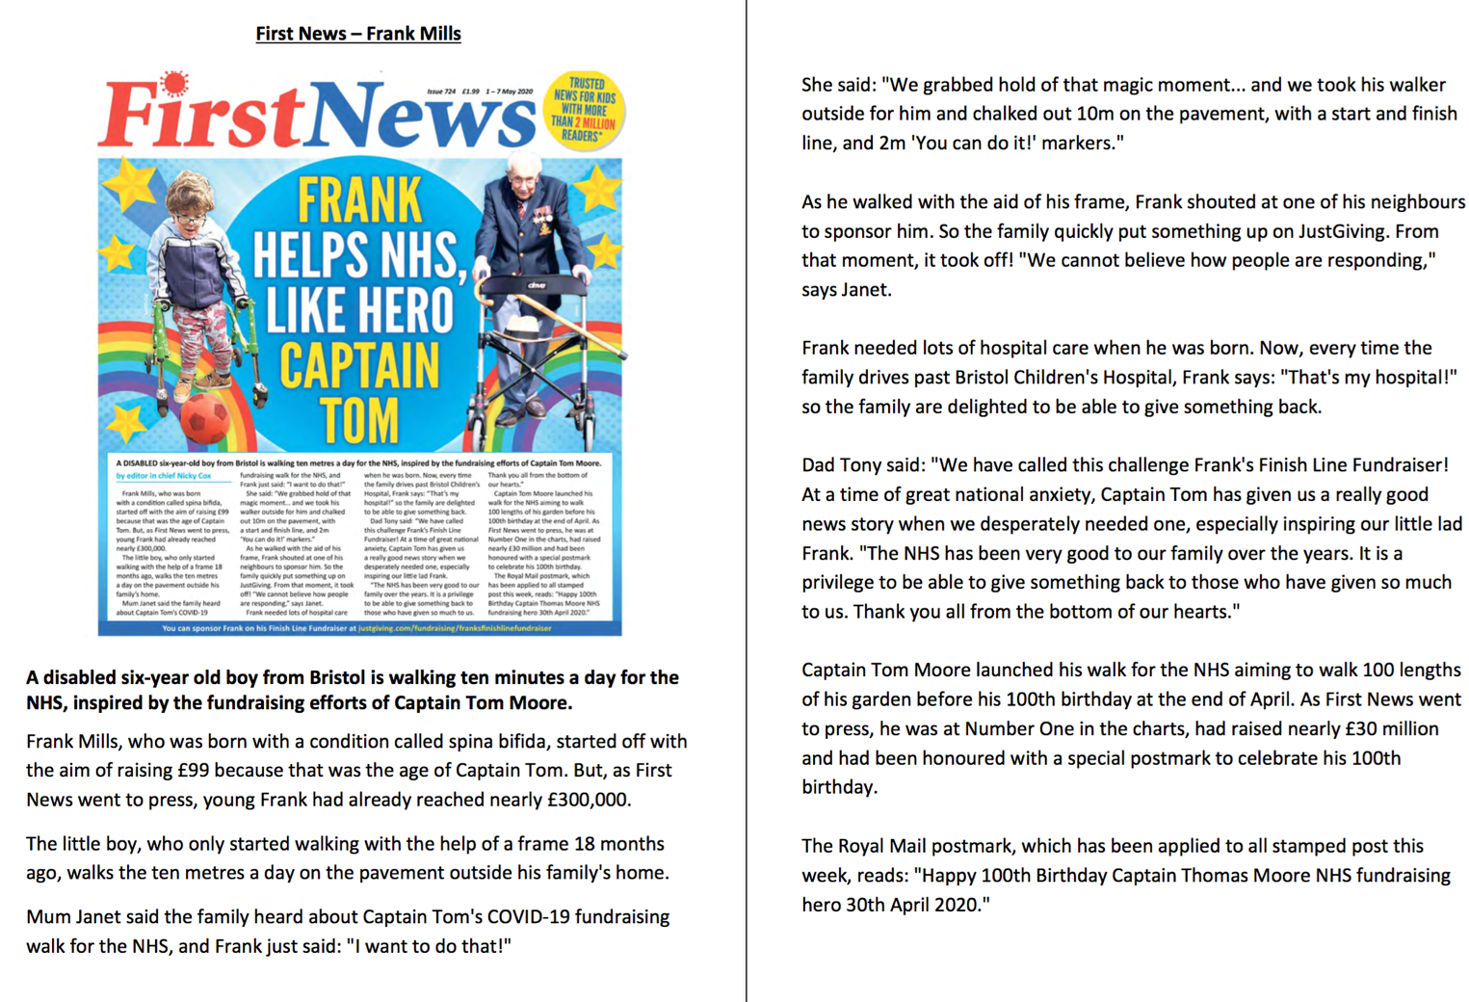
Now answer the questions below.
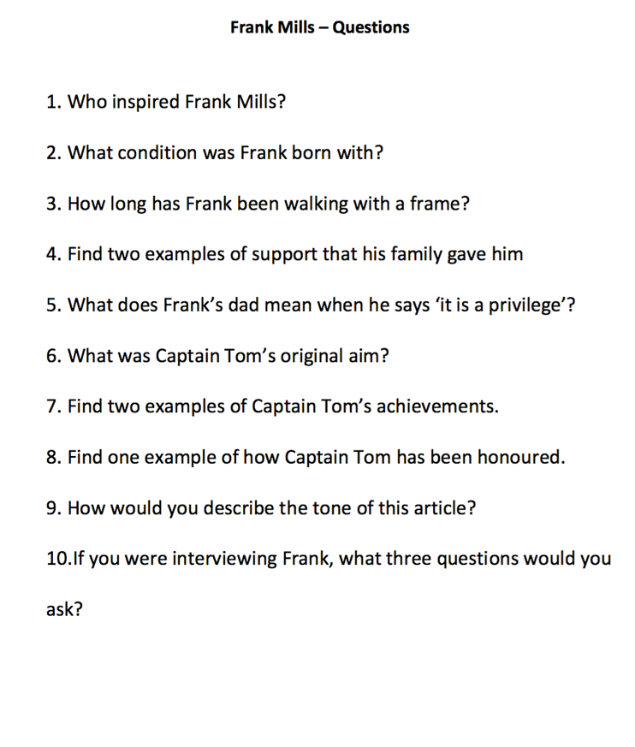

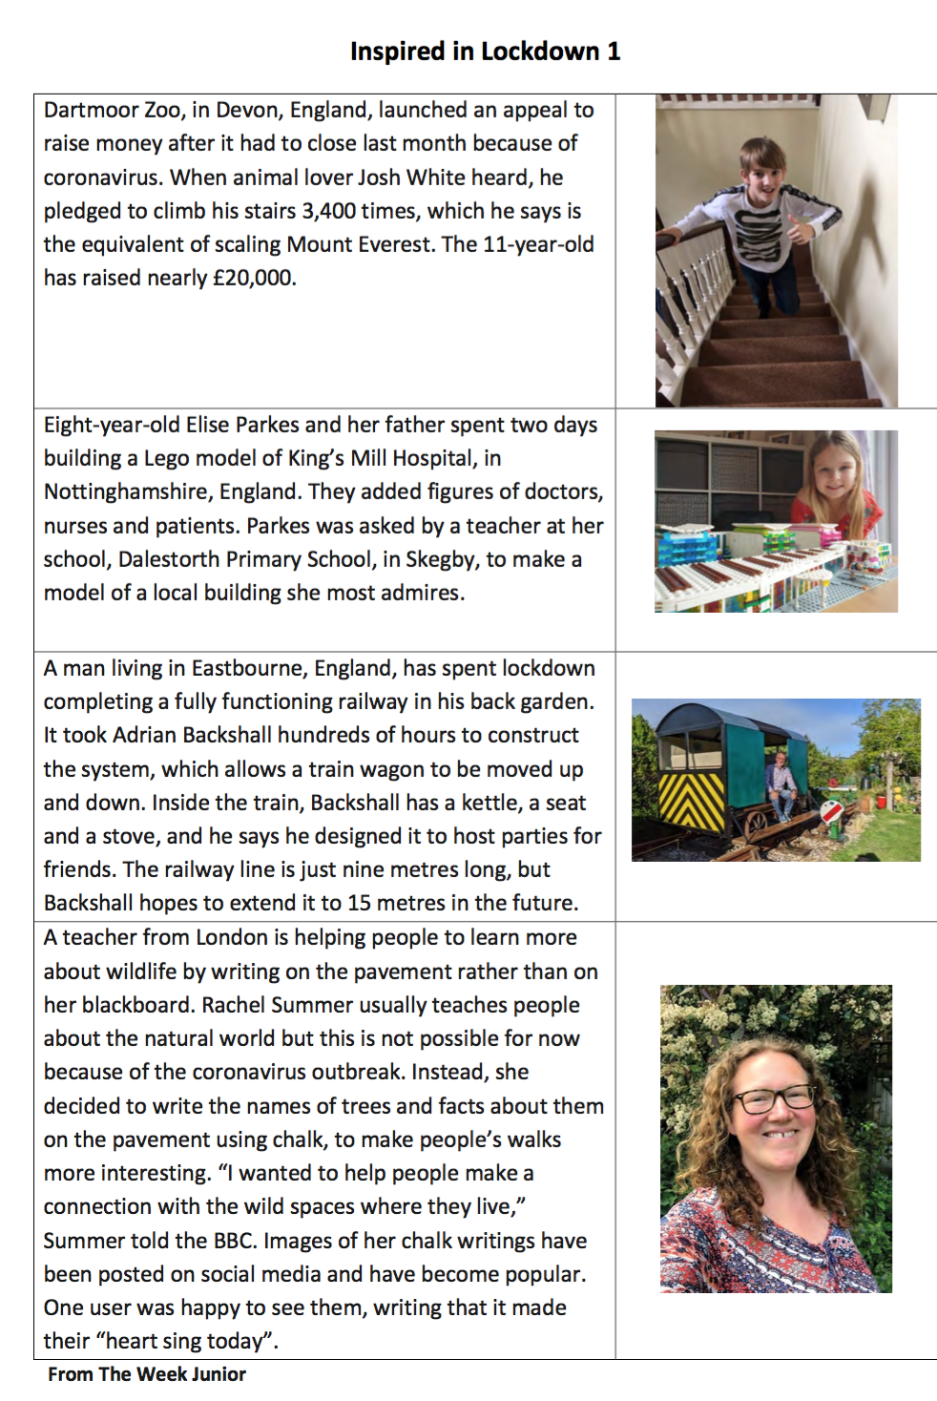
Now read about people who have been inspired around the country to do something to help others.
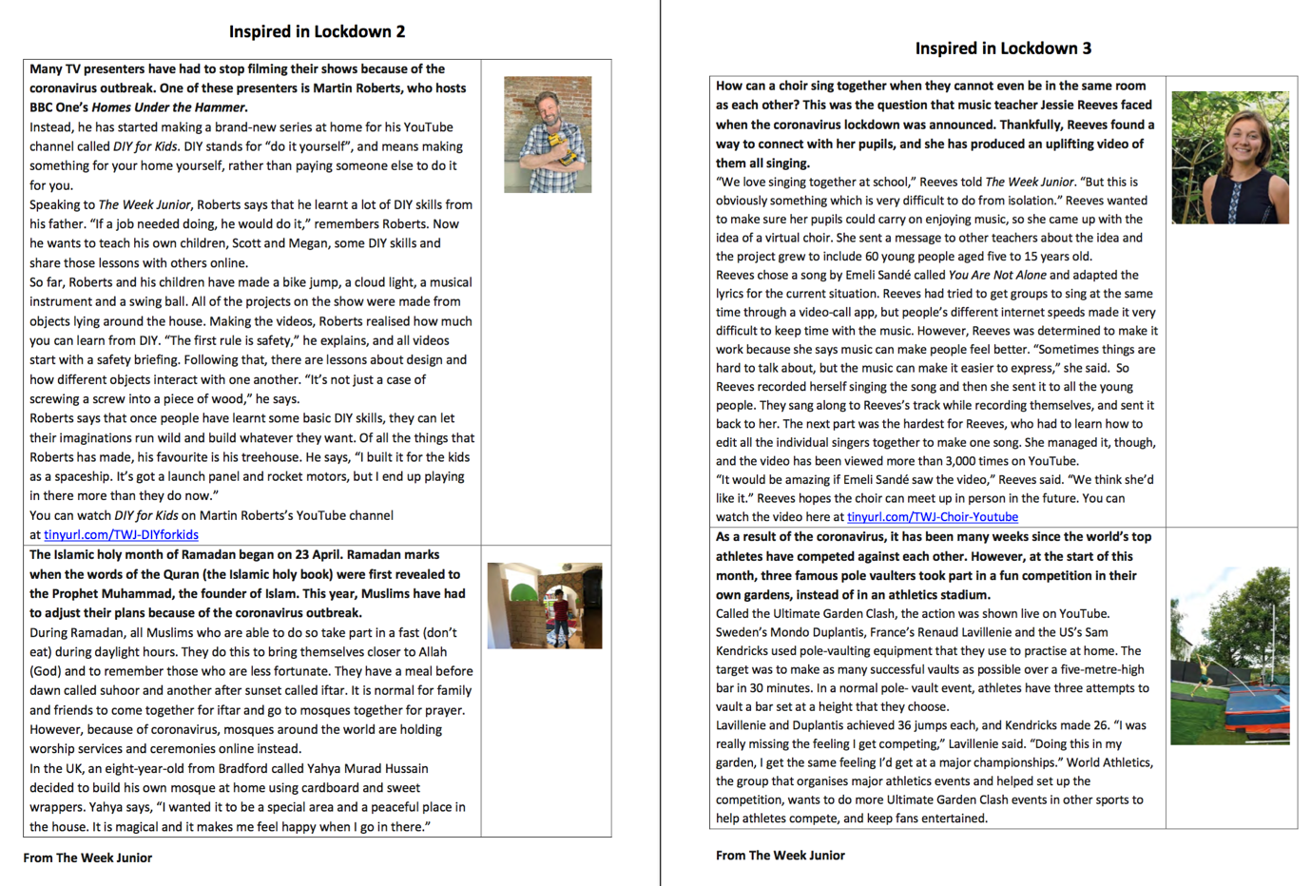

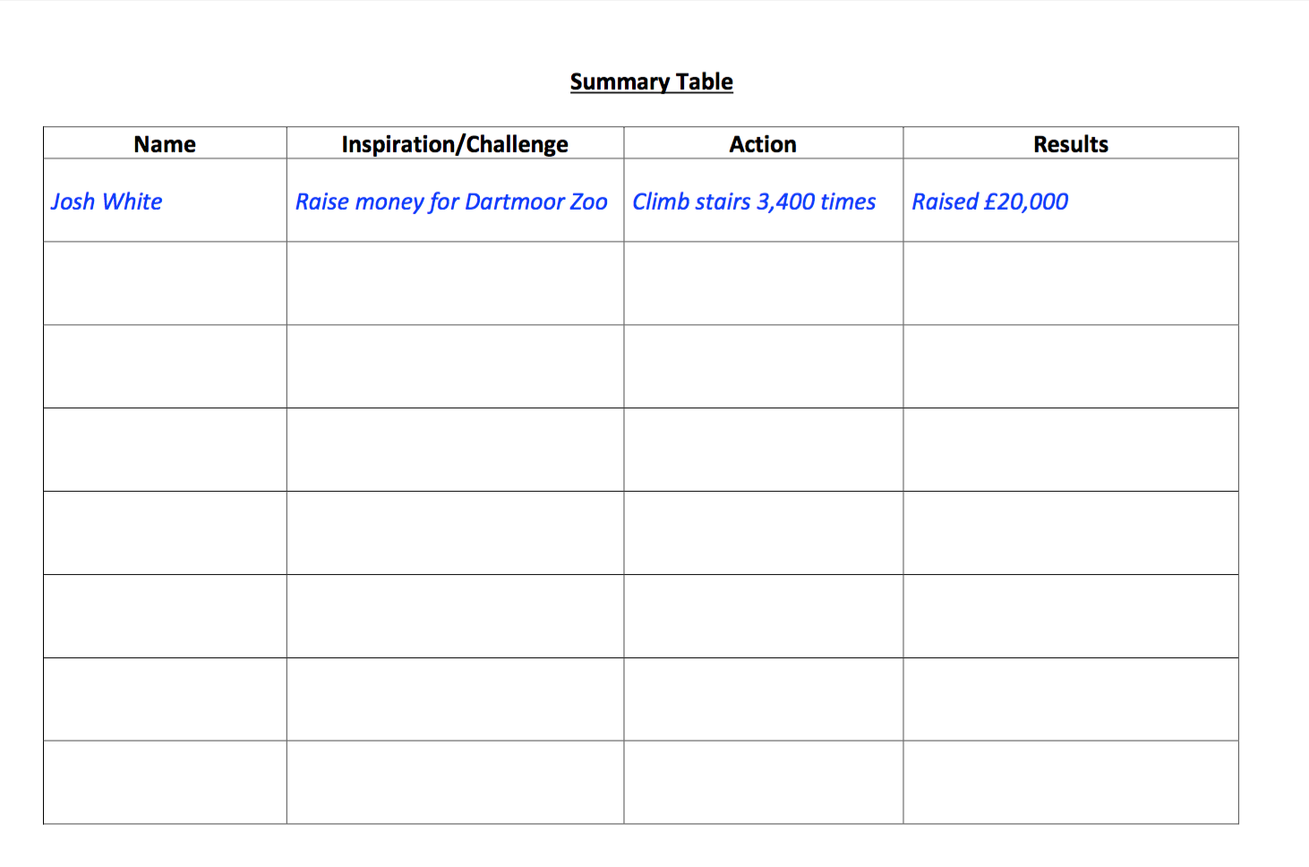

Next, fill in the sheet below to sum up what people have been doing around the country. The first one has been done for you.
Have a go at the worksheet below and think about your own experience of lockdown. What could you do?
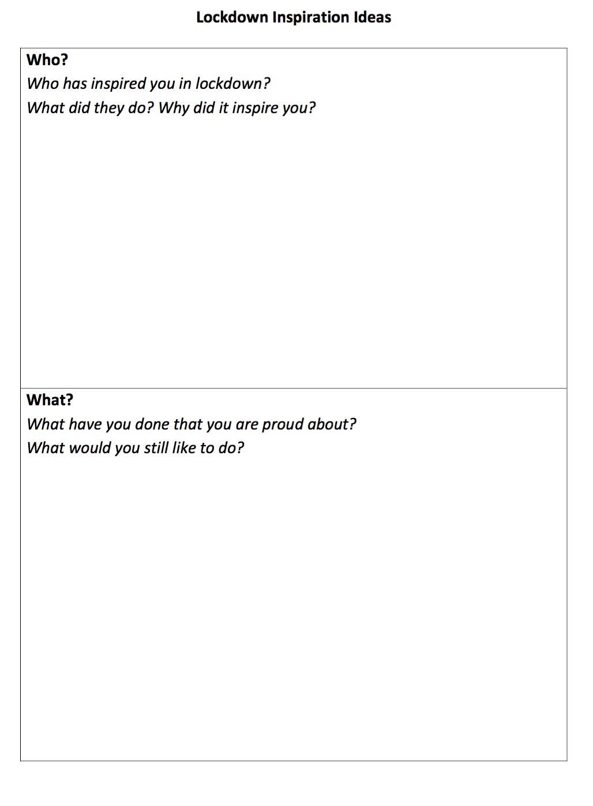

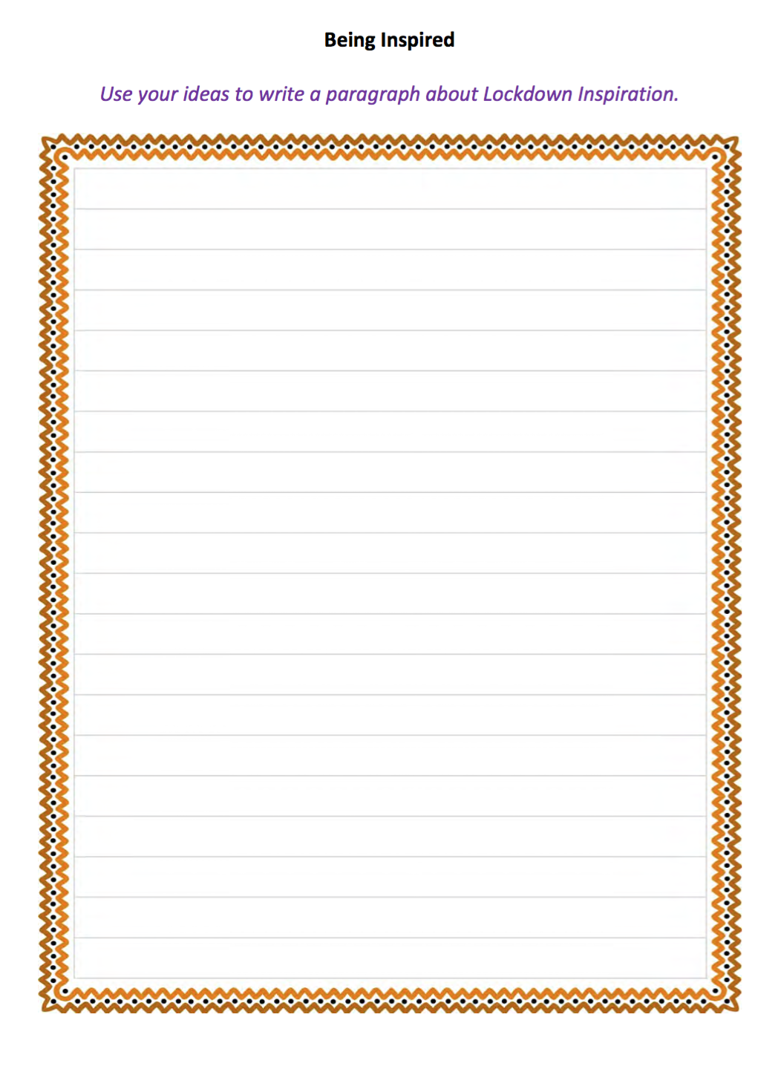
Now write a short piece of writing about everything you that has inspired you recently. It could be the NHS, someone in your family who has taken care of others, someone you have seen in the news etc. Also, talk about what you could do/have done to inspire others. This could be a phone call to a family member who is lonely, creating a piece of art or just helping around the house.

