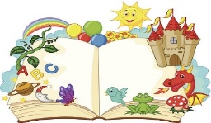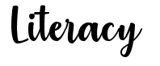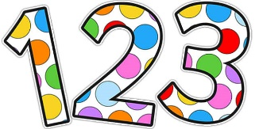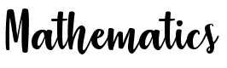

**Rhyme time:**

This week we will be practicing the Nursery Rhyme 5 little speckled frogs. You can find a video for it here… <https://www.youtube.com/watch?v=WSC-gHBU_d0>

Can you make up actions for it? Maybe you could draw 5 frogs sitting on the logs and use the picture to help learn the song.

We will be learning to recognise the letters t and p. Have a go at finding objects which start with a ‘p’ or a ‘t’ sound.

**Shape:**

This week in school we will be recapping Circles, squares and triangles. We will be looking at where they are in the environment. We will see if we can match shapes together. Have a hunt through your house. What shapes can you find?

Our number of the week will be 6, see if you can count it out with objects. Can you find one more and one less than it?

Now that some children are back in school we are spending lots of time talking about Lockdown and our bubbles. <https://www.literacyshed.com/bubbles.html> Here is a lovely video about bubbles which we’ve used. Watch the video and talk about where you would like to travel if you were in the bubble?

I hope you’re all keeping happy and healthy, it’s been lovely to have children back in school and hear from you over the phone if not. Take care,

love Mrs Bonham xxx