Subject | Week 11
English | Comprehension  Complete the attached reading comprehension about Victorian toys.
Grammar  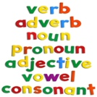 | Grammar revision  Try the grammar challenges, which bring together some of the things you have been practising over the last weeks.
Maths | White rose hub: https://whiterosemaths.com/homelearning/year-5/  Children should watch the daily videos and try the attached exercises for Week 4 Lesson 2 – Equivalent fractions.
Discussion point with your family | 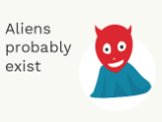  It’s one of those things that everyone has an idea about! What do you think and why?
If you would like access to the answers sheets then please email enquiries@st-michaels.school

